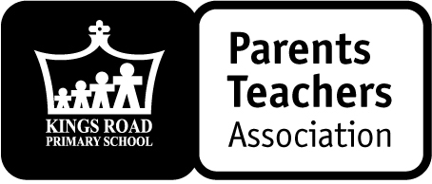
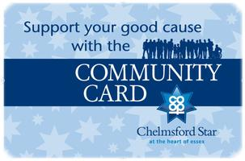
CO-OP COMMUNITY
CARD SCHEME

Dear Parents,
Originally launched in July 1999, the Community Card Scheme has grown from strength to strength and we are one of over 200 groups that have a Community Card account. The cards may be used at any Co-op store in the Chelmsford area including the Quadrant in the city centre.
The scheme is simply another way of fundraising for our school and all you need to do is present your card at the till every time you shop just like other supermarket loyalty cards. With each purchase, we are awarded stars that convert into cash at a rate of £5 per 1,000 stars and then the Co-operative donates an extra 50% to the school when we draw out our balance!
If you would like to have one, please complete the slip below, return it to the School Office and we will arrange for one of the cards to be issued to you via your child as soon as possible. May we apologise for this extra administration but we are now required to maintain a register of cardholders.
Please think about having a Kings Road Primary School PTA Community Card or encouraging a friend or relative that regularly shops at the Co-op to have one - the scheme is integral to fundraising for the school, and it is free!
Yours sincerely,
Any questions please contact the PTA:
Email: pta@kingsroad-pri.esssex.sch.uk
Tel/text: 07779 127579
Talk to: any PTA Committee Member

Emma BerquezPTA
PTA Chair

To: PTA via School Office, Kings Road Primary School

Yes please, I would like a new Co-Operative Community Card (PLEASE PRINT CLEARLY)
Contact Details:
Name:....................................................................... Child’s Class: ......................................
Landline:........................................................... Mobile: ...........................................................
Email:.........................................................................................................................................

